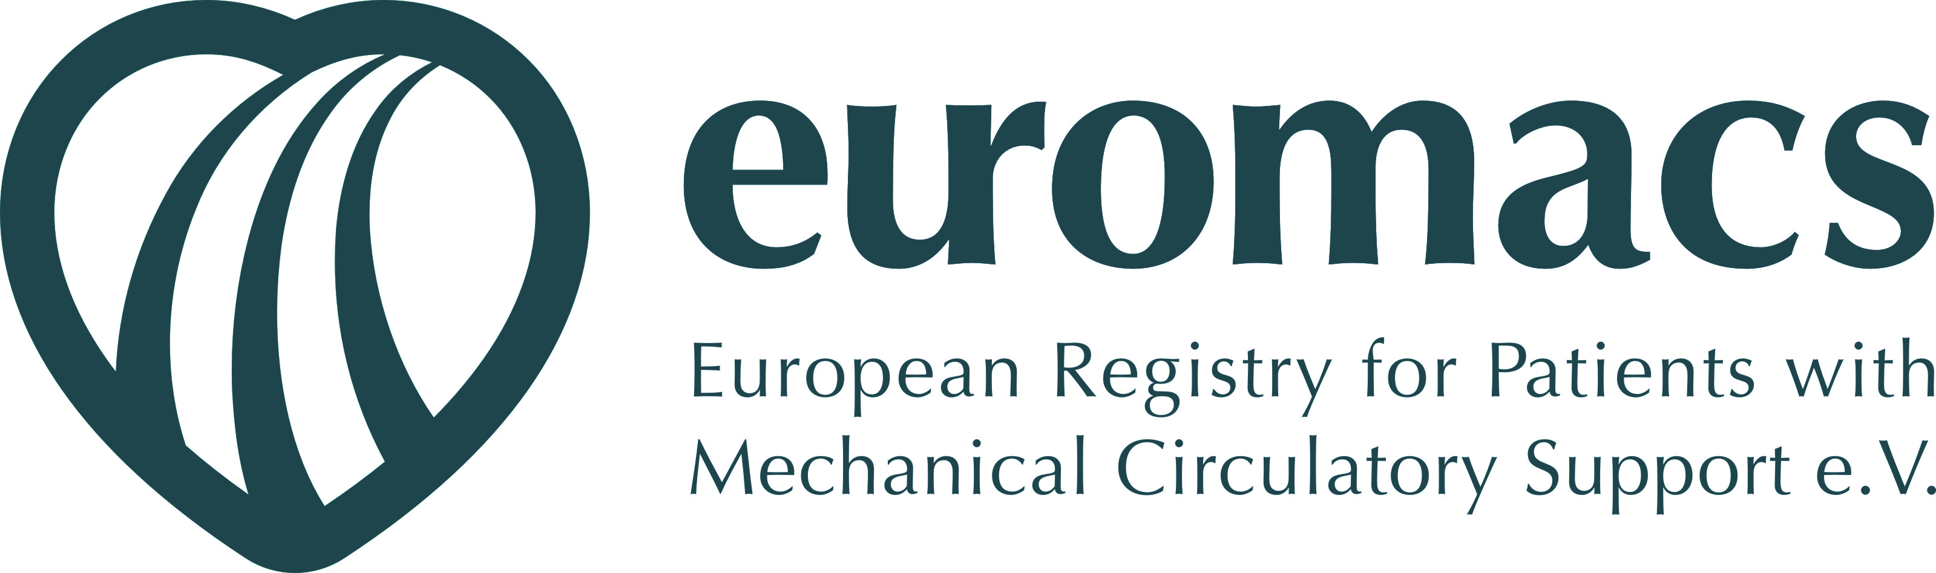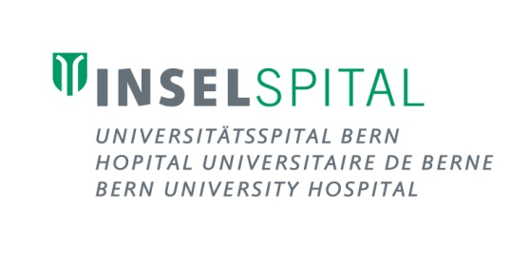

**Registration Form**

**3rd European Training Symposium for Heart Failure Cardiologists**

**and CV Surgeons, June 24 – 25, 2016, Berne/Switzerland**

**Mechanical Circulatory Support and Heart Transplantation:**

**Taking a deep dive and looking over the boarder**

I would like to register for the ETS Symposium from June 24 - 25, 2016 in Berne, Switzerland:

I need **accommodation** (single room) from / to:

**Symposium Dinner** on Friday, June 24, 2016, at 7.30pm (attendance by registration only, you will be given a ticket)

□ Yes, I like to join □ No, I can’t attend

□ Vegetarian Meal Food Allergy:

Name: First Name:

Title: Profession:

Working Place / Department:

Full Adress:

E-Mail address:

**The registration fee for attendees is EUR 570.00.**

The fee includes registration fee, 2 nights hotel accommodation in a nice hotel, coffee breaks during the symposium, lunch on Friday and the symposium dinner on Friday evening. The registration fee is payable in advance to the symposium.

Information on the hotel and bank account details will be given in the confirmation letter.

Place and date: Signature:

**Please send** the completed **registration form by June 13**, 2016, to [alessandra.witsch@insel.ch](mailto:alessandra.witsch@insel.ch) or by Fax to +41 31 382 10 69. Contact phone: +41 31 632 44 64.